Name: ________________________________________ Date: ______________
Enduring Issues Essay – River Valley Civilizations Mrs. Valdes

Document #1: The First Form of Writing: Cuneiform

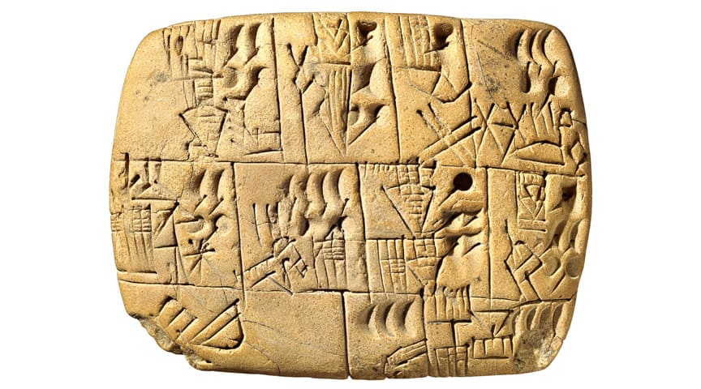

The Sumerians developed the first form of writing called “cuneiform” to maintain business records. It was mostly used in trade, where merchants recorded information such as the amount of grain traded. The Mesopotamians also used writing to record daily events like astronomy.

Cuneiform evolved as a simple pictograph. For instance, the pictograph for a horse might be a small image of a horse. The writer had to drag the tip of a stylus across wet clay to create a shape. It was hard to remember every character and it would take 12 years for a person to learn to write in cuneiform.

The symbols were reduced to 600 words by 2900 BC and scribes (people who were hired to write) eventually changed the writing from a drawn image to a stamp or imprint using a reed stylus with a wedge-shaped tip. Cuneiform script was used by the Assyrians, Elamites, Hittites, Babylonians, and Akkadians for about 3,000 years.

Document #2: The Chariot
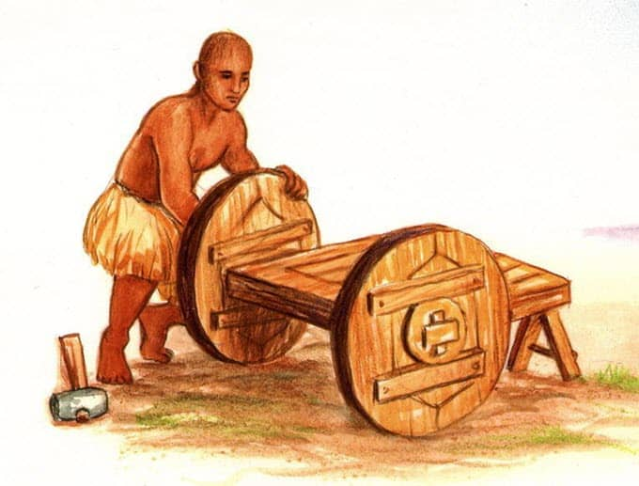

Over time, humans learned to domesticate horses, bulls, and other useful animals and the invention of the chariot or carriage followed on from their domestication. The chariot was the first means of personal transportation, and has been used for years in warfare, sport, and for general use. The structure of the earliest chariots was from light wood with a bentwood rim. The first chariot appeared around 3200 BC in Mesopotamia and was adopted by almost every civilization until motorized transportation came into existence. Chariots were mainly used for personal transportation by royalty and the wealthy.

Document # 3: The Sailboat

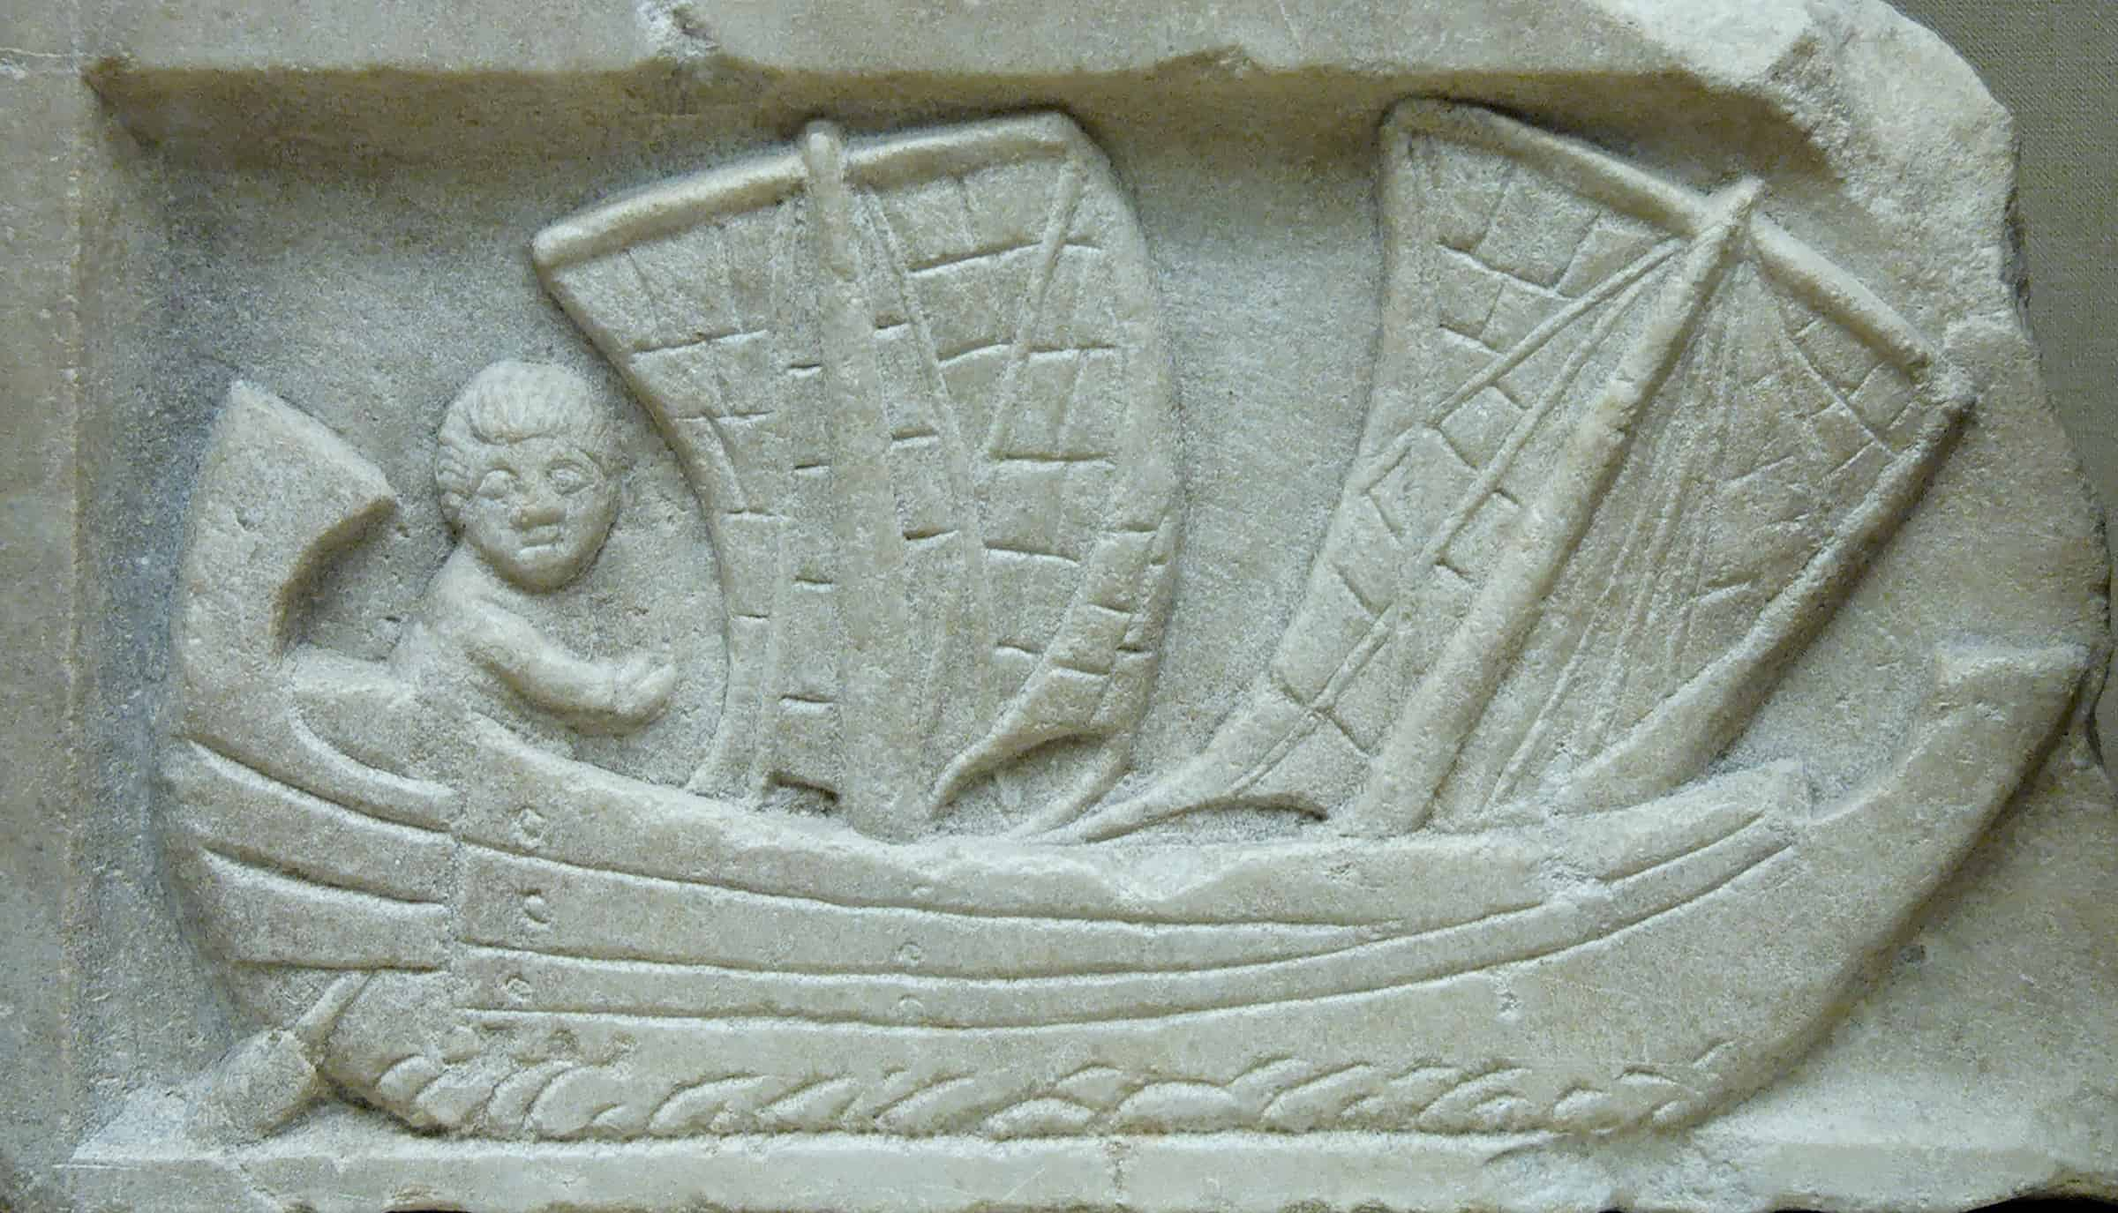

Transportation by land was difficult and took an enormous amount of time. The Sumerians realized that transportation via sea would be a lot easier and more convenient. The first boat was invented and used on rivers and needed to be navigated by humans. The first sailboat was a simple, primitive design and aided in trade and commerce. It was initially used to cross the Tigris and Euphrates rivers for fishing and to explore other areas.

The primitive sailboat was square in shape and the sail was made of cloth. The direction of the sailboat couldn’t be changed. If the wind didn’t blow in the direction they wanted to go, they had to wait for the wind to change in their favor.

Document #4: The Calendar and Clock

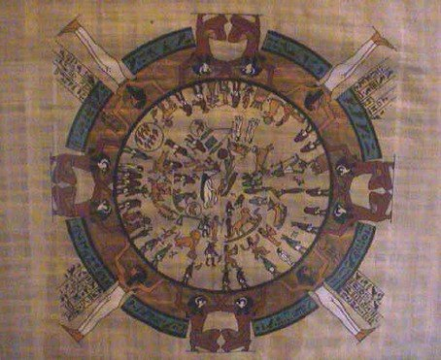

The Egyptians divided time into three main periods: the inundation [rainy] season (akhet), which lasted for one-third of the year; the sowing and growth of the crops (perit); and the harvest (shemu). These three seasons each consisted of 120 days and made up one calendar year. To mark the beginning of each year, they chose the rising of the Dog Star, visible to the naked eye. After some time, it became evident that the calendar was short, but the start of the civil year coincided with the beginning of the agricultural year.

The Egyptians were among the first to divide their days into parts. Obelisks – slender, four-sided monuments – were used as sun clocks from 3500 BC and their moving shadows enabled people to separate the day into parts, starting at noon. Later on, they invented the first portable shadow clock which was so lightweight that people could carry it with them. A rod was marked with 12 sections and a shadow of the rod would tell you what time it was. In addition, records and historical documents were kept of each king’s reign.

Document #5: Egyptian Medicine

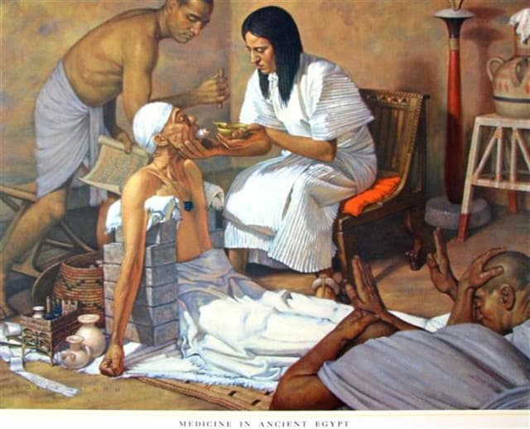

The Edwin Smith Papyrus is a medical text on surgery from ancient Egypt written around 1600 BC. It shows that the Egyptians invented medical surgery, predating the Hippocratic Oath by a thousand years. It describes surgical cases of head, neck, and chest injuries and includes a list of instruments used during surgery. The first instruments were found within the tomb of Qar, who was known as “the physician of the palace and keeper of the secrets of the king.” Ancient Egypt was also known to be the starting point of neuroscience.

Egyptian medicine was a mixture of magical and rational treatments. Both methods were equally valid: when the cause was visible and objective, scientific treatments were used and when the cause was hidden (and could be a punishment from the gods or the ill wishes of enemies), magic was employed. Everything was based on the Egyptians’ great knowledge of anatomy as a result of mummification.

